Do not make a copy of this page i.e. D1 Instructions and Rubric. If I end up clarifying something, I will add a comment about what was changed.
Be sure to not delay doing your sprint kickoff and task management meeting for Deliverable 1 - do it as it is normally scheduled, as early as possible. This allows the team to get started early and solve any issues that arise better.
Everyone needs to read this document about quality checking of work. This is input into making your quality checking policy for your project collaboration.
Here is a link to examples of all the different parts of the project deliverables for all the project assignments.
Note: So I can give better feedback, please MINIMIZE cutting and pasting in revised versions of a section into a Google doc from another doc editor (or from the google doc itself) - instead, make the edits in the google doc directly. Otherwise, it mangles the edit history and I can’t easily see what has changed. Just like project stakeholders in real projects, if you make it hard for me to give good feedback, the consequence is you will get less good feedback.
Make sure to download your projects' documents and check them into your Github repo as well in a folder Documentation/Deliverable1; this is also good practice in Industry as a backup. That is required and you will get -20 unrecoverable on the assignment if you do not do that. Include any documents you revised in that folder as well. It's like a snapshot of all your documents at that point in time. For example see the documents folder in Team-Flash from a prior year, but use editable file formats when possible (e.g. .docx for your google docs instead of PDFs): folder structure
Submit each file as a link to a Google Document and share it with gregory.nelson@maine.edu with full editor privileges and all group members (do not share it using "Anyone at UMaine with the link can..."). Note that any revisions/resubmission will also be done in those same Google Documents, to make it easier to understand what has changed.
For example, your text submission should look like this:
Project Description: <web link>
User Story document: <web link>
Product Backlog: <web link>
Sprint Backlog: <web link>
Sprint Backlog (after kickoff meeting, if using the export option): <web link>
Sprint Backlog (at end of deliverable due date, if using the export option): <web link>
Software Requirements Specification (SRS): <web link>
Sprint Review: <web link>
Github Repo: <web link>
Issue/Task Management Software: <web link> (for example, Github Issues; make sure my gregory.nelson@maine.edu Google account can access the software with full privileges)
Grading Rubric:
Start by going through the feedback on the prior deliverables and create & assign tasks for any unaddressed comments/feedback, both comments on documents and also in the overall feedback on Brightspace. If that’s not available yet, create a task for that by copy-pasting this paragraph.

Updated Project Description Document ( /5)
- Based on the comments from deliverable 0.
- If the comments were not addressed, the document will be marked as 0.
- If the comments are partially addressed, the document will be marked as 2.5.
- You must document a changelog by replying to the Google document comments when you think an issue has been addressed. You must also reply to comments saying what you didn’t address.

Updated User story document ( /5)
- Based on the comments from deliverable 0.
- If the comments were not addressed, the document will be marked as 0.
- If the comments are partially addressed, the document will be marked as 2.5.
- You must document a changelog by replying to the Google document comments when you think an issue has been addressed. You must also reply to comments saying what you didn’t address.

Regularly export this from Github Projects option for product and sprint backlog (rubric details are underneath this)
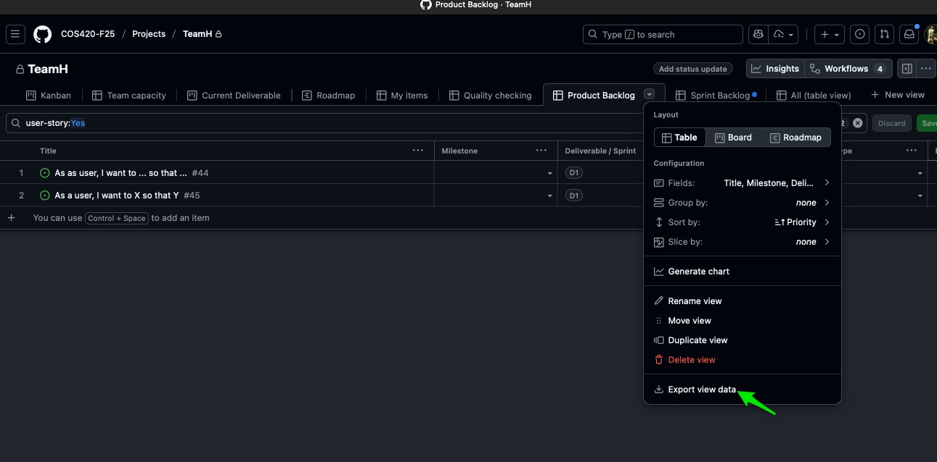
To save your team time, you will export that data directly from Github Projects. Your team will need to use the Github Project template here.
(and you can view a list of the custom fields here, which are also visible in the example issues in the template)
You will use the template above for your team's project (you are able to reimport any issues you already made if you make a new project, see below). This template then lets you export the product and sprint backlogs using the provided views in that template. If using this option of exporting it, for the sprint backlog you should make two exports during each sprint/deliverable, 1) right after your sprint kickoff meeting where everything is assigned, and 2) at the end of the deliverable. (This will also show if people are being assigned work then not doing their work, using the assignee field.)
If needed, to import issues you've already created to a new Github Projects, to issues, select them, then click projects and you can add them by clicking on the new project
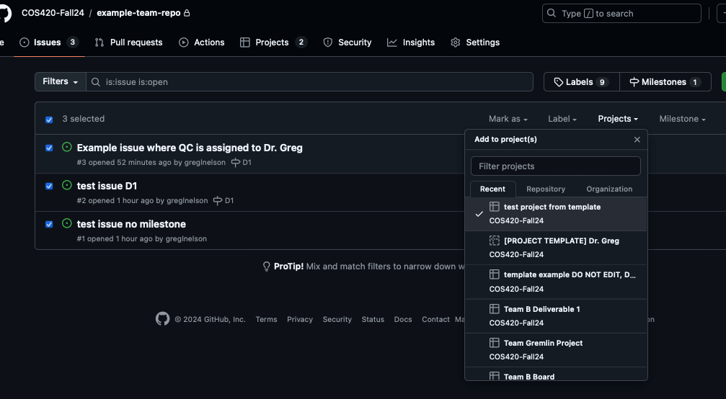

Product Backlog ( /10)
- You will regularly export this from Github Projects for each deliverable.
- Your Product Backlog items/user stories should have the user story field set to Yes so they show up in the Product Backlog view correctly. You don't need to fill in the story points, story type, or priority. You also don't need to assign them to sprints until you are actually implementing them with code during a sprint.
- Product backlog and sprint backlog should match i.e. product backlog items in the sprint backlog need to have the same IDs etc. If they do not match deduct -2 points.
- Make sure that all of your user stories are in the product backlog. For any missing user story deduct -1 point.
- All columns based on the projects’ details document should be in the product backlog and must be filled out. For any missing column or missing information deduct -2 points.
- (Old example(s) here with a different spreadsheet format, but still helpful)

Sprint Backlog 1 (/10)
- You will regularly export this from Github Projects for each deliverable.
- Contains only the stories (user stories and technical and non-technical stories) you commit to working on and delivering for this Deliverable. Should reflect the product backlog. That is, all the user stories that are assigned to this Sprint in the product backlog, should be shown in this Sprint Backlog.
  - For any missing user story, deduct -2 points.
  - If the Sprint Backlog 1 does not reflect the product backlog, deduct -5 points.
- You should also have other tasks in the backlog, like documentation, requirements, UI mockups, etc. As covered in class sessions, these are called non-technical stories.
  - You don’t need to have all the tasks for all future Deliverables for the project, just the ones for the sprint that you planned to do (and perhaps completed)
  - See the sprint backlog from past years in the examples
    - (Old example(s) here with a different spreadsheet format, but still helpful)

- All columns based on the projects’ details document should be in the product backlog and must be filled out. For any missing column or missing information deduct -2 points.
- Using the "regularly export this from Github Projects" option for this, your sprint backlog items should have the deliverable field set to your current deliverable. For the sprint backlog you must make two exports during each sprint/deliverable, 1) right after your sprint kickoff meeting where everything is assigned, and 2) at the end of the deliverable. (This will also show if people are being assigned work then not doing their work, using the assignee field.) Be sure you have the deliverable set to the appropriate deliverable so these show up on the export correctly, i.e.
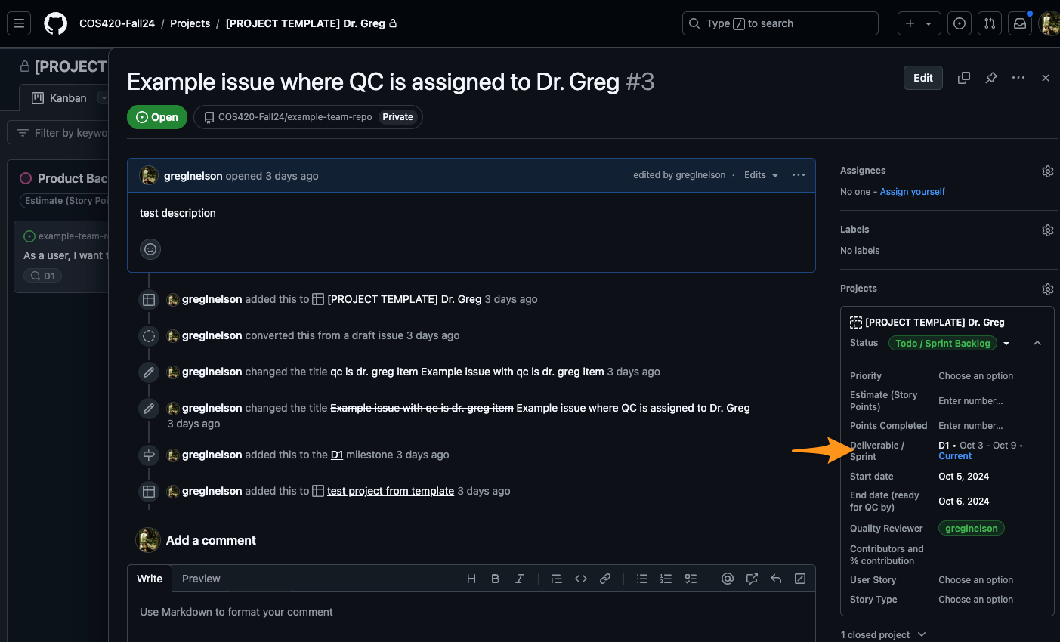
  - You don't need to fill in story points, story type, or priority; those are often used by professional teams, your team may find them helpful, but they are not required.
  - The tasks should all be assigned to the correct sprint i.e. the current sprint, as mentioned above in the screenshot.

Github (/5)
- Contributions should be consistent and all students contribute.
- If a student does not contribute to Github, the student will be graded as 0. You can each commit different files, or make changes to the README. For this deliverable, any people unfamiliar with Github don’t need to make commits yet.

Quality Checking Policy (/5) (See the guide here)

Kanban (/15)
- Kanban board should be created and shared with the group (on your issue/task management platform i.e. Github Issues)
- The normal option is to just use Github Projects for your kanban (template has some example issues/tasks in it)
  - Here is a link to the F26 one, in case you can’t access the link above (same template)
- Kanban board should show progress and activity (i.e. be updated and used).
- If no progress is shown, the grade for this part will be 0.
- The Kanban must have quality checking tasks or use the quality checker field, and tasks for integrating the deliverables together, with enough time to assign tasks to fix that before submission. That integration and quality checking work should be distributed and also done by people who are not the PM, otherwise it’s too much work for the PM.
  - If this is missing, -5 points.
- There should be 15-30 tasks for this Deliverable and any revisions for the previous Deliverable. Each task should be small.
  - If < 15 tasks, -2.5 points
  - If any tasks are nonsensical or made just to get to 15, -10 points
  - If there are more than 1-2 tasks with the entire team assigned to them, -2.5 points for each. E.G. if you do that 10 times you will get -25 points
  - Each task should have the grading feedback/rubric information inside the task, for that task. The task assignee should have everything they need to know to do the task well, by just looking at the task. (Also for the quality checker).
    - -2 points for each task missing this
Sprint Review (/5)
- Should follow the template. See example(s) here.
- Use the template as an agenda for the sprint review meeting. Step through each point as a team, have a discussion and have someone take notes. The team should review the notes during the meeting in a shared Google Doc to make sure everyone is heard, and anyone can edit the notes.
- This document is generally 1-2 pages.
- Should be written for this past sprint / week (i.e. for Deliverable 1, Deliverable 1 and Revisions for Deliverable 0)
- You should NOT assign the sprint review as a task for a single person. You should do a sprint review meeting. Use the sprint review template as an agenda for the sprint review meeting. Step through each point as a team, have a discussion and have someone take notes. The team should review the notes during the meeting in a shared Google Doc to make sure everyone is heard, and anyone can edit the notes.
- For any missing item from the template, deduct 2 points.
- Sprint Review document should contain all prior Sprint Reviews as well, with the most recent at the top (the first sprint review happens in Deliverable 1). This is so you can read over the whole history of the project reviews and notice any patterns.

System Requirements Specification (SRS) ( /30)
- See SRS template here.
- Has about 15 – 30 functional requirements
  - If the number of FR is below 15, -5 points
  - Put them in Section 4
- Has about 5 – 10 non-functional requirements.
  - If the number of NFRs is below 5, -5 points
  - Put them in Section 5
- Begin the requirements by selecting a few of the features that you would like to develop first and write the requirements for them. Continue with the next features if you still need to have more requirements.
- Use the syntax taught in class, i.e., “The system shall …”, etc. Review the slides and any other guidance on requirements as needed.
- For each wrong requirement, deduct -2 points.
- For each conflicting/contradictory requirement, deduct -2 points.
- If there are no UI low-fidelity mockups/wireframes, deduct -20 points.
  - This is here so you get started. Put these in Section 3.1
  - You should have at least 2-3 wireframes of the most important features (not high fidelity mockups like are in the example Deliverable 2 level of detail SRS examples)
- Use cases and/or stimulus-responses are not required.
- Other sections will be filled in in the next deliverable. Here’s an example for the eventual Deliverable 2 level of detail.

Software (/10)
- The implementation should have been started.
  - If there is no code/HTML/scripts in Github, this part will be graded as 0.
- You must assign specific parts of this to specific people, such as the readme, the build environment, reproducing and quality checking the build instructions work, any tasks for additional learning by the team e.g. looking into technical topics for later in the development, etc.
- Setting up the build environments and the necessary dependencies.
  - You do not need to have any significant progress on developing your application. Focus on setting up the build environment. You can use create-react-app (or otherwise create your project structure i.e. files and folders).
- Your README file should detail the installation and build process for your application. Make sure it works on each person’s machine.
  - Submit screenshot(s) or a single video showing the app running on each person’s machine
  - If there is nothing, deduct -5 points.

Total = /100

